Modern Application Development 1 Project Report

1. Student Details
Name: | Adithya Sabarish Saravanan
Roll Number: | 22f3000018
Email: | 22f3000018@ds.study.iitm.ac.in
About Me: | I am online degree student pursuing the BS in data science degree from Germany. I have completed my master’s degree with AI specialization in Germany and due to my interest in Mathematics, I am pursuing my career and working now as Cryptographic Algorithm developer at Infineon Technologies.

2. Project Details

Project Title: Hospital Management System

Problem Statement:
To build a Hospital Management System (HMS) web application that allows Admins, Doctors, Patients to interact with the system based on their roles.

Approach:
The app was built using Flask, SQLALCHEMY and other Jinja libraries as the backend framework with a modular structure. It allows patients and doctors to effectively interact and render functionalities to the user based on their needs. The final visual features are handled by HTML template rendering.

3. AI/LLM Declaration
I used GitHub Co-pilot:
- Only to improve the python classes (database relations). Like for example, while defining the backref relationships between relations.
- HTML templates: To improve the manifestations of Buttons, and for bootstrap based table formatting.
- The extent of AI/LLM usage is around 10–12%, limited to code suggestions and style formatting.
All final implementation logic, debugging, and integration were done manually.

4. Technologies and Frameworks Used
Technology / Library | Purpose
Flask | Core backend web framework
SQL Alchemy | Object Relational Mapper for SQLite database
Jinja2 | Template engine for rendering dynamic HTML pages
Bootstrap 5 | Frontend styling and responsive design
SQLite | Lightweight local database for storing user data

5. Database Schema / ER Diagram
Tables:
- Admin — stores admin details (id, name, email, password)
- Doctor— store doctors’ details (id, username, mail, password, name, blacklisted, other additional details)
- Patient— stores patient information (id, username, mail, password, name, blacklisted, other additional details)
- Department— stores different department information (id, name, description)
- Appointment— contains appointment details between doctor and patient. (doctor id, patient id, date, time, status)
- Doctor availability — To save the availability that the doctor provides to enable appointment bookings by patient. (id, doctor id, date, morning time and evening time)
- Patient history — To store patient treatment history provided by doctor. (id, patient id, appointment id, diagnosis, prescription, notes)
The following ER diagram created using SQLite Intelli View VS code extension:
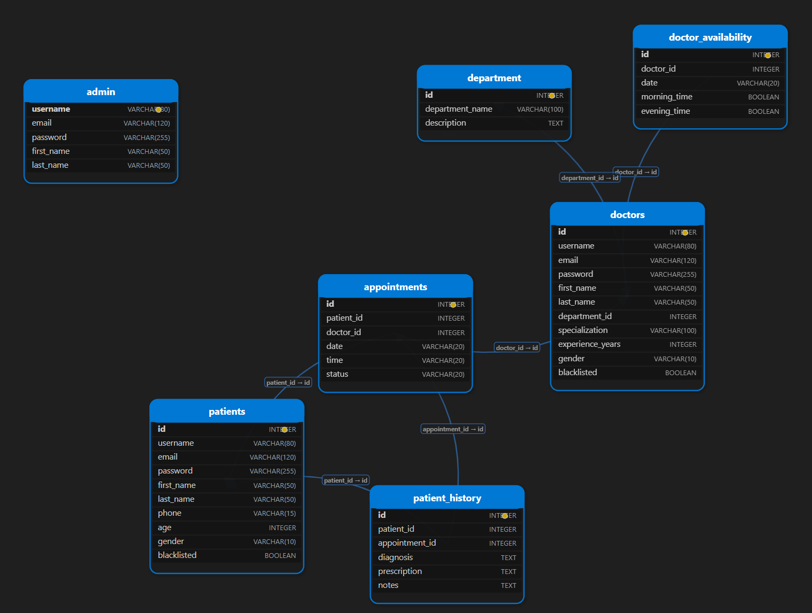
Relationships:
- Many-to-one: Doctor → Department: Many doctors belong to one department.
- Many-to-one: Appointment → Patient: Many appointments for one patient.
- Many-to-one: Appointment → Doctor: Many appointments for one doctor.
- One-to-many: Department → Doctor: One department has many doctors.
- Many-to-one: Doctor availability → Doctor: Many availabilities for one doctor.
- Many-to-one: Patient history → Patient: Many histories for one patient.
- One-to-one: Patient history → Appointment and Appointment → Patient history: Each patient history is linked to one appointment, and each appointment can have at most one patient history.

6. Architecture and Features (optional)

Architecture Overview:
- app.py – main Flask application entry point
- /application – database models in models.py, functionalities of admin, doctor and patient and then login/registration handling in a modularized manner.
- /instance – contains sqlite3 database
- /templates – Jinja2 HTML templates
- /static – CSS styling files

Implemented Features:
- Admin:
  - Add, update, delete, and remove/blacklist doctor/patient profiles (name, specialization, availability).
  - View and manage all appointments.
  - Search for patients or doctors by name/specialization.
- Doctor:
  - Mark appointments as Completed or Cancelled.
  - Provide their availability for the next 7 days.
  - Update patient treatment history like provide diagnosis, treatment and prescriptions.
- Patient:
  - View their own treatment history and appointment history with diagnosis and prescriptions.
  - Book as well as cancel appointments with doctors.
  - Register and login themselves.
Additional Features:
- Flash message that the user can voluntarily close after performing an operation. Example – After successfully performing registration, appointment booking, appointment canceling, etc.

7. Video Presentation
Drive Link:
https://drive.google.com/file/d/your-video-link-here
(Accessible to all with “View” permission.)

